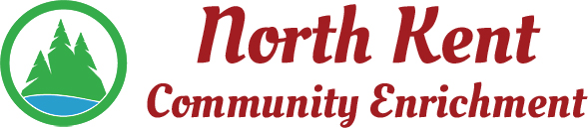
204 E. Muskegon Cedar Springs, MI 49319
616-696-7320 www.myNKCE.com
Agenda for Regular Meeting of Monday September 11, 2023

- Call to order

- Approval of agenda
- Consent Agenda
  - Approval of July 2023 Minutes (August Meeting Cancelled)
  - Approval of July/August Financial Statements

- Information and Discussion Items
  - Sparks Grant
  - Audit
  - Fall Events
  - New Enrichment Classes

- Action Items
  - Confirm Next Meeting October 2, 2023
- Adjourn

