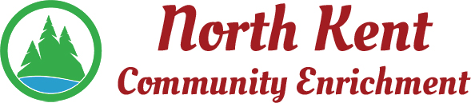
204 E. Muskegon Cedar Springs, MI 49319
616-696-7320 www.myNKCE.com
Agenda for Regular Meeting of Monday Jan 9, 2023

- Call to order

- Approval of agenda
- Consent Agenda
  - Approval of December 2022 Minutes
  - Approval of December Financial Statements

- Information and Discussion Items
  - Winter Events
  - Possible Senior Citizen Dance
  - Daddy Daughter Dance
  - Mother son Nerf War

- Action Items

  - Confirm Next Feb 6, 2023
- Adjourn

