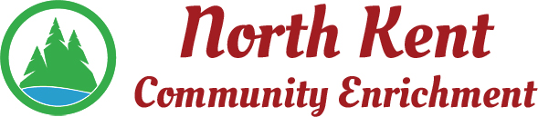
204 E. Muskegon Cedar Springs, MI 49319
616-696-7320 www.myNKCE.com
Agenda for Regular Meeting of Monday Dec 4, 2021 @ 6:00 NKCE OFFICE

- Call to order

- Approval of agenda
- Consent Agenda
  - Approval of October 2022 Minutes/ No November meeting
  - Approval of October/November Financial Statements

- Information and Discussion Items
  - Possible Winter Event with City Impact
  - Daddy Daughter Dance/Mother son Nerf war
  - Course Demographics
  - Fall Events

- Action Items
  - 2023 proposed monthly board meeting dates

  - Confirm Next Meeting Jan 9, 2023
- Adjourn

