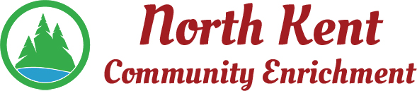
204 E. Muskegon Cedar Springs, MI 49319
616-696-7320 www.myNKCE.com
Agenda for Regular Meeting of Monday March 13, 2023 @ 6:00 PM

- Call to order

- Approval of agenda
- Consent Agenda
  - Approval of January 2023 Minutes
  - Approval of January/February Financial Statements
- Information and Discussion Items
  - Nerf War/Daddy Daughter Dance recap
  - Senior Citizen Dance
  - Winter/Spring Events Flyers
  - Sports Camps
  - Possible Michigan Sparks Grant – Sue Wolfe
- Action Items
  - Confirm Next April 10, 2023
- Adjourn

