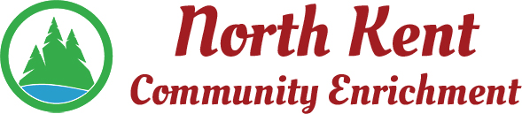
204 E. Muskegon Cedar Springs, MI 49319
616-696-7320 www.myNKCE.com
Agenda for Regular Meeting of Monday September 12, 2022

- Call to order

- Approval of agenda
- Consent Agenda
  - Approval of July 2022 Minutes (August Meeting Cancelled)
  - Approval of July/August Financial Statements

- Information and Discussion Items

  - Audit
  - Algoma ribbon cutting
  - Fall Events
  - Youth basketball discussion

- Action Items
  - Confirm Next Meeting October 3, 2022
- Adjourn

