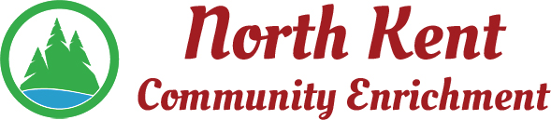
204 E. Muskegon Cedar Springs, MI 49319
616-696-7320 www.myNKCE.com
Agenda for Regular Meeting of Monday October 3, 2022

- Call to order

- Approval of agenda
- Consent Agenda
  - Approval of September 2022 Minutes
  - Approval of September Financial Statements

- Information and Discussion Items
  - Daddy daughter Dance - Feb 4th
  - Youth sports
  - Fall Events
  - By law changes

- Action Items

  - Confirm Next Meeting November 7, 2022
- Adjourn

