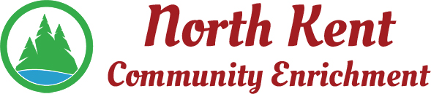
204 E. Muskegon Cedar Springs, MI 49319
616-696-7320 www.myNKCE.com
Agenda for Regular Meeting of Monday July 11, 2022 @ 6:00 PM
- Nominations for:
Chair
Vice-Chair
Treasure
Secretary

- Voting of Officers – Chair, Vice-Chair, Treasure, Secretary

- Call to order

- Approval of agenda
- Consent Agenda
  - Approval of June 2022 Minutes
  - Approval of June 2022 Financial Statements

- Information and Discussion Items
  - Who will be handling financials?
  - NKCE name change
  - Sports/Events
  - Solon Ice Cream social July 14th, 7pm

- Action Items

  - Confirm Next Meeting August 1, 2022
- Adjourn

