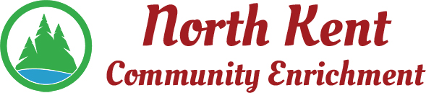
204 E. Muskegon Cedar Springs, MI 49319
616-696-7320 www.myNKCE.com
Agenda for Regular Meeting of June 7, 22 @ 4:00pm

- Call to order
- Approval of agenda
- Consent Agenda
  - Approval of May 2021 Minutes
  - Approval of April Financial Statements
  - Approval of May Financial Statements

- Information and Discussion Items
  - Nominate officers
  - MML liability & property pool
  - Proposed/approve Budget
  - Sports/Events
  - Meeting every two months
  - Quickbooks $1,900 yearly.
  - Ice cream social
  - 80/20 or 70/30 for tennis camp?
  - Name change NKCE
- Action Items
  - Confirm Next Meeting July 11 or August 1, 2022?
- Adjourn

