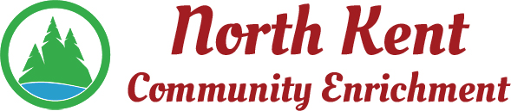
204 E. Muskegon Cedar Springs, MI 49319
616-696-7320 www.myNKCE.com
Agenda for Regular Meeting of Monday April 11, 2022 @ 6:00 PM

- Call to order

- Approval of agenda
- Consent Agenda
  - Approval of March 2022 Minutes
  - Approval of March Financial Statements

- Public Comment
- Information and Discussion Items
  - Spring/Summer programs
  - 3 on 3 basketball tournament
  - Pay raise for Tracy
  - Future of NKCE
- Action Items

  - Confirm Next May 2, 2022
- Adjourn

