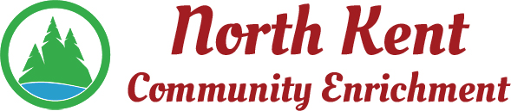
204 E. Muskegon Cedar Springs, MI 49319
616-696-7320 www.myNKCE.com
Agenda for Regular Meeting of Monday Feb 7, 2022 @ 6:00 PM IN PERSON

- Call to order

- Approval of agenda
- Consent Agenda
  - Approval of January 2021 Minutes
  - Approval of January Financial Statements

- Information and Discussion Items
  - Daddy Daughter Dance
  - Nerf War
  - Pickleball
  - Winter/Spring Events
  - High School Dance
  - Future of NKCE
- Action Items

  - Confirm Next March 7, 2022
- Adjourn

