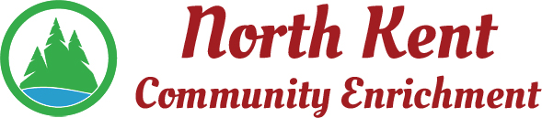
204 E. Muskegon Cedar Springs, MI 49319
616-696-7320 www.myNKCE.com
Agenda for Regular Meeting of Monday Dec 6, 2021 @ 6:00 PM IN PERSON

- Call to order

- Approval of agenda
- Consent Agenda
  - Approval of November 2021 Minutes
  - Approval of November Financial Statements

- Information and Discussion Items
  - Boys Basketball Uniforms
  - Pay for nightly employees
  - NKCE name
  - Fall Events – Pickleball
  - Financial report

- Action Items

  - Confirm Next Meeting Jan 3, 2022
- Adjourn

