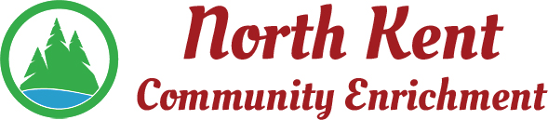
204 E. Muskegon Cedar Springs, MI 49319
616-696-7320 www.myNKCE.com
Agenda for Regular Meeting of Monday September 14, 2020 @ 6:00

- Call to order

- Approval of agenda
- Consent Agenda
  - Approval of August 2020 Minutes
  - Approval of August Financial Statements

- Information and Discussion Items
  - Virtual Run
  - Fall events
  - Pickleball courts
  - Solon/Algoma facilities
  - Audit Letter
  - MML Dividend Letter

- Action Items

  - Confirm Next Meeting October 5, 2020
- Adjourn

