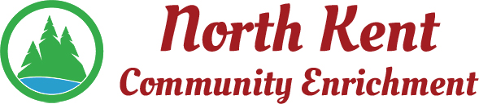
204 E. Muskegon Cedar Springs, MI 49319
616-696-7320 www.myNKCE.com
Agenda for Regular Meeting of Monday August 3, 2020 @ 6:00 PM via Zoom

- Call to order

- Approval of agenda
- Consent Agenda
  - Approval of July 2020 Minutes
  - Approval of July Financial Statements

- Information and Discussion Items
  - New Algoma Rep – Alyssa Ladd
  - August Concert in the Park
  - Discussion on Fall events
  - When to bring Jaime and Tracy back on payroll

- Action Items

  - Confirm Next Meeting September 14, 2020
- Adjourn

